Ege Balcıoğlu
22 JUNE 2026
Pentomino Pandemonium
Game desıgn document v1.2

Table of Contents
1. Overview 3
1.1. Platform 3
1.2. Art style and Hardware Requirements 3
1.3. Document Version Control 3
2. Game Elements 4
2.1. Pentominoes and Their Names 4
2.2. Tiles (and The Grid) 7
2.3. Blockers 8
2.4. Buttons 9
2.5. Music/SFX 10
3. Game Mechanics 10
3.1. Dragging and Dropping a Pentomino 10
3.1.1. Dragging Over Tiles 10
3.1.2. Dropping On Tiles 11
3.1.3. Dropping On Other Pentominoes 11
3.1.4. Dropping On Blockers 11
3.2. Rotating a Pentomino 11
3.2.1. Exception 11
3.3. Flipping a Pentomino 12
3.3.1. Exceptions 12
3.4. Next Level 12
3.5. Skipping Levels 12
3.6. Controls: A Summary 13
4. General Level Design 14
4.1. Main Menu 17
4.2. Credits “Menu” 17
5. Game Progression 18
5.1. Advancing a Level 18
6. Tools & Assets 18
6.1. Sprites 18
6.2. Soundtrack 21
A. Appendix: Levels and Their Solutions 22
A.1. Level 1 22
A.2. Level 2 23
A.3. Level 3 24
A.4. Level 4 25
A.5. Level 5 26
A.6. Level 6 27
A.7. Level 7 28
A.8. Level 8 29
A.9. Level 9 30
A.10. Level 10 31
A.11. Level 11 32
A.12. Level 12 33
A.13. Level 13 34
A.14. Level 14 35
A.15. Level 15 36
A.16. Final Level 37
B. Appendix: Unplanned Features That Could Be Added in The Future 38
C. Appendix: References 38

1. Overview
Pentomino Pandemonium is a simple, minimalistic puzzle game of filling given square-tiled grids with shapes called “pentominoes” (further described in Section 2.1: Pentominoes and Their Names). In order to complete the game, the player will be required to complete 16 levels, each containing a classical pentomino puzzle.
This document is designed with the following foremost concern: Each subsection should be able to quickly be skimmed and the reader should be able to gather all the relevant information related to the subject by skimming it. Thus, later sections may intentionally contain redundant information already covered in previous sections.

1.1. Platform
This game is intended to be playable on Windows PCs (currently playable on Windows 10 and 11), with a traditional .exe format.
Download the latest version of the game here: https://github.com/egebalcioglu1999/Pentomino-Pandemonium

1.2. Art style and Hardware Requirements
The art style of this game is minimalistic, with almost monochromatic pentomino sprites interacting with simple square tile sprites. Hence, this game should be playable on PCs regardless of hardware specs.

1.3. Document Version Control
- Version 1.0:
  - Added main game mechanics
  - Added animations for buttons and pentominoes
  - Added relevant sprites and music
  - Added the main menu
  - Added levels 1-7, and the Final Level (which is named as such)
- Version 1.1:
  - Added the option to skip levels (for debugging purposes)
  - Fixed a bug related to flipping not always working with certain pieces
  - Moved level 7 to level 15 and added a new level 7
  - Added new levels 8-15
- Version 1.2:
  - Added a room called Credits (for Music), with an associated button
  - Added a Back button inside the “Credits” room to go back to the main menu
  - Added sprites for the buttons mentioned above.

2. Game Elements
The game consists of a main menu (detailed in Section 4.1) and 16 levels (detailed in Section 4 and Appendix A).
The main menu contains the title of the game, a “Play” button to start the game (from Level 1), and a “Quit” button to exit the game.
Each level contains a title, 9 or 12 unique pentominoes, and an initially hidden button that advances to the next level. Titles have not been given a dedicated subsection because they are merely inanimate pieces of text with no further details to be discussed.

2.1. Pentominoes and Their Names
Pentominoes are two-dimensional shapes that are made of 5 square “cells” that are identical in size and orientation, with each cell sharing an edge with another cell. They are similar to dominoes (two square cells) found in the eponymous game Dominoes and tetrominoes (four square cells) found in the video game Tetris. This document will also refer to a pentomino as “a piece” when appropriate.
Fitting pentominoes into grids with square tiles is a classical type of puzzle, even if it isn’t as well-known as other similar puzzles like Tangram.
It should be noted that cells of pieces in this game do not have pips (numbers), like Tetris and unlike Dominoes.
There are 12 unique pentominoes (not counting different orientations), and each piece is traditionally named after a letter of the English alphabet: F, I, L, N, P, T, U, V, W, X, Y, and Z.
Pieces can be dragged and dropped. They can usually also be rotated and flipped. All of these mechanics are detailed in the relevant subsections of Section 3. Only one piece can be dragged at a time, and a pentomino can only be flipped or rotated while being dragged.
Pieces are displayed over other types of objects.
While being dragged, a pentomino will follow the cursor’s location continuously, unless it is covering a tile. If it is, it will “snap” onto the grid and only move in lateral increments equal to the side-length of a tile.
Below is a list of all 12 pieces with their names:
- The F piece: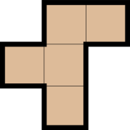
- The I piece: 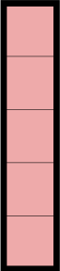
- The L piece: 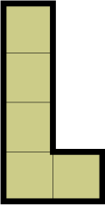
- The N piece: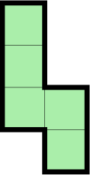
- The P piece: 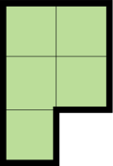
- The T piece: 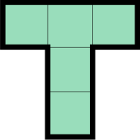
- The U piece: 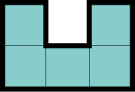
- The V piece: 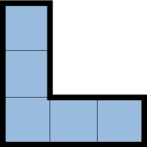
- The W piece: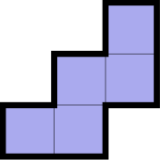
- The X piece: 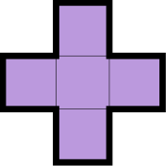
- The Y piece: 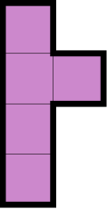
- The Z piece: 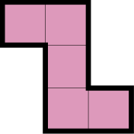
The images listed above are currently used in-game as sprites. See Section 6.1 and Appendix C for detailed information.

2.2. Tiles (and The Grid)
The tiles are small square-shaped objects that are meant to be covered up with pentominoes. Each tile is identical in shape, size, and sprite. Below is the sprite of a single tile:

The grid is a big shape made of numerous adjacent tiles (and blockers, detailed in the next subsection), which is different for each level. The goal of each level is to cover up the entire grid of the level with the pentominoes provided by the level without any overlapping cells.

Below are some images of the grid of two different levels:
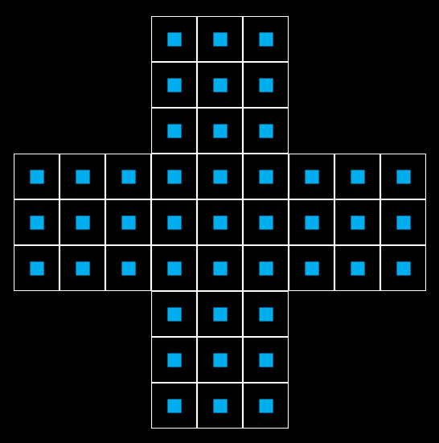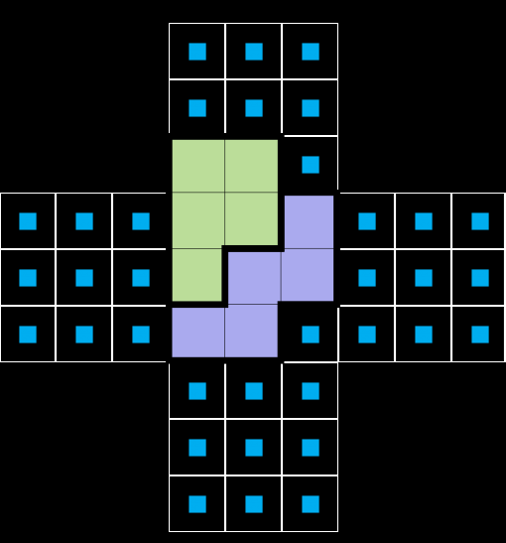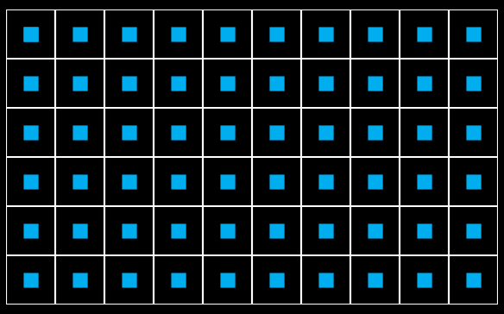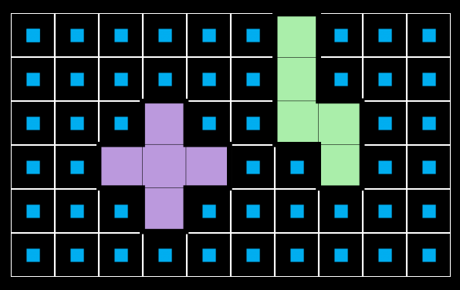
The images on the left show the empty grids of two different levels while the images on the right depict two pentominoes placed onto each grid. (The grids shown belong to Levels 4 and 1, respectively. See Appendix A for details.)

2.3. Blockers
Blockers are invisible square-shaped objects that sit on the periphery of the grid and the rest of the level. They are identical in shape and size to a tile. Below is the sprite of a single blocker used in the engine, even though it is not seen in-game:

The purpose of the blockers is to prevent pieces from being placed only partially into the grid. In other words, if a cell of a pentomino is not on a tile while another is, the blockers are always placed in a way such that a cell of that piece is covering a blocker, which blocks the piece from being placed.
Below is the grid of a level as seen in the game engine (with blockers visible):
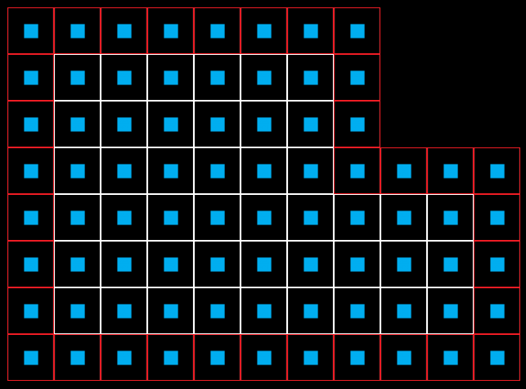
(The grid above is from level 9. See Appendix A for details.)

2.4. Buttons
Five types of buttons are present in the game, each named after the text on it. They are listed below:
- “Next” Button: This button is present in all levels and is initially invisible. When the level is solved (detailed in Sections 3.4 and 4.1) or intended to be skipped (see Section 3.5), it becomes visible. When this button is clicked while visible, the game advances to the next level. If the game was already on the final level, the game closes.
- “Play” Button: This button is present in the main menu. When clicked, the game starts Level 1.
- “Quit” Button: This button is present in the main menu as well. When hovered over with the cursor, the background music changes to a sombre tone. When clicked, the game closes.
- “Credits” Button: This button can be found in the main menu as well. When clicked, the game displays the credits for the game’s music (Kevin MacLeod).
- “Back” Button: This button is the only button found in the Credits “menu”. When clicked, the game returns to the main menu.
Each button has a default sprite and an alternate sprite that is displayed when the mouse cursor hovers over it. These are given in detail in Section 6.1.

2.5. Music/SFX
There exists a simple background music for all levels and the main menu, detailed in both Section 6.2 and Appendix C, which changes only upon hovering the “Quit” button. The music of the game is otherwise never interrupted. No other SFX is present.

3. Game Mechanics
Pentomino Pandemonium is meant to be played entirely with a mouse (except for skipping levels, detailed in the corresponding subsection). Thus, it intentionally has a limited number of mechanics/ controls. These controls (again, except for skipping levels) are designed to be as intuitive as possible, since the game does not have a dedicated screen that explains the controls.
Some features that currently aren’t planned to be implemented but could be added to the game in the future are listed in Appendix B.

3.1. Dragging and Dropping a Pentomino
To start dragging a pentomino, the player can hover over it with the cursor and left-click it with the mouse. A pentomino being dragged will follow the cursor’s position closely. Only one piece can be dragged at a time.
A pentomino being dragged is displayed over every other object, including other pentominoes. In general, pentominoes are displayed over other objects.
“Dropping” a piece means to have it stop being dragged, and this is done by left-clicking the piece being dragged again.
A piece being dragged has a smooth, graceful, continuous animation. This is not a trailing particle effect on the path the piece takes; the movement itself is animated.
While not overlapping with a tile or another piece, a piece being dragged is dropped where the cursor is at the moment of the second click. (This drop location is currently implemented as the exact location of the cursor at the time of the click, but it doesn’t have to be that. Merely dropping sufficiently close-by would also be desirable.)

3.1.1. Dragging Over Tiles
While dragging a piece over a tile, the player will feel some resistance from the piece about following the cursor. The piece will only move in horizontal or vertical increments equal to the side-length of one tile. This will feel like “snapping” on the grid. The animation during the snapping will be fast, but it will still not be instant; the piece will gracefully slot into the grid.
Dragging a piece over a blocker will not have such a special interaction despite blockers’ similarity to tiles.

3.1.2. Dropping On Tiles
If a moving piece is covering an empty tile (and not a blocker), a left-click will drop the piece where it last “snapped” onto the grid.
This should not (and currently does not) require any additional code implementation, but it still should be kept in mind.

3.1.3. Dropping On Other Pentominoes
If a piece being dragged is overlapping with another piece, a left-click will drop the piece and automatically move it where it initially spawned. This additional movement will still not be instant; it still will have a smooth but fast movement animation.
Currently, no behaviour is defined for the case when there is already another pentomino on the piece’s spawn-point.

3.1.4. Dropping On Blockers
If a piece being dragged is overlapping a blocker AND a tile at the same time, its behaviour on a dropping left-click will be the same as if it is dropped on another pentomino.
The piece should be dropped normally if it is covering a blocker but not a tile.

3.2. Rotating a Pentomino
While a pentomino is being dragged, the player can scroll the mouse wheel in either direction to rotate that pentomino in increments of ±90° with respect to the cursor’s position, keeping its cells aligned with the grid.
Similar to dragging, rotating a piece is not instant, and instead has a short and smooth animation associated with it.

3.2.1. Exception
Due to its 90° rotational symmetry, the X piece cannot be rotated in order to avoid redundancy.


3.3. Flipping a Pentomino
While a pentomino is being dragged, the mouse can be right-clicked to flip (mirror) the pentomino with respect to the position of the cursor and an axis that is laterally aligned with the grid. Whether this axis is horizontal or vertical is irrelevant.
Similar to dragging, flipping a piece is not instant, and instead has a short and smooth animation associated with it.

3.3.1. Exceptions
Due to their obvious bilateral symmetries aligned with the grid, the following pieces cannot be flipped: I, T, U, X. These pieces are shown below. This function may be removed later simply to allow the player more freedom at the cost of redundant moves.

Note that flipping is still allowed for the pieces for which a flip is equivalent to a 90° or 180° rotation (V, W, Z). The redundancy of those pieces being flipped is less obvious. No example image is provided to avoid cluttering the document.

3.4. Next Level
A level is solved by covering every tile on the grid with a pentomino. When this happens, a button appears on the bottom of the screen. This button advances the player to the next level. If the player is on the final level when this button is clicked, the game simply ends and closes.

3.5. Skipping Levels
During a level, pressing a predetermined “Skip” key - currently designated as the “D” key - gives the player the option to advance to the next level without completing it. Pressing this key again removes the option to skip the level (until the key is pressed a third time, and so on). “D” stands for “Debug”.
This function is mainly intended for debugging, but could be kept in the game for the player to quickly skip levels and get to a desired level.
This function is implemented via tricking the level into thinking that it is completed, and making the Next Level Button visible and clickable (pressing the key again makes the button invisible and non-interactable, and so on).

3.6. Controls: A Summary
Refer to the subsection of each mechanic for more details:
- Left Mouse Click:
  - on a stationary pentomino: Start dragging the pentomino.
  - on a pentomino being dragged: Drop the pentomino where it is. Special interaction with tiles, blockers, and other pentominoes.
  - on a button: Execute the button’s function (usually: advance to the next level).
- Right Mouse Click:
  - Flip the pentomino being dragged with respect to the cursor, with an axis aligned with the grid. (Exceptions apply to the I, T, U, and X pentominoes.)
- Mouse Wheel Scroll Up/Down:
  - Rotate the pentomino being dragged in increments of ±90°. (An exception applies to the X pentomino.)
- “Skip” key (currently bound on D):
  - Toggle the option to be able to skip the current level.

4. General Level Design
Each level consists of a simple pitch-black background, a title for the level (“Level X” or “Final Level”), up to 12 pentominoes separate from each other, a grid that consists of up to 60 adjacent tiles (and appropriate blockers), and an initially invisible “Next” button.
If a tile has an edge that is not adjacent to another tile, a blocker is placed adjacent to that edge.
Blockers are always invisible. The pieces, the title, and the tiles are always visible. The button is only visible when the level is solved/intended to be skipped.
This section continues on the next page.

The pieces, the title, and the button are always initially placed outside of the grid. The initial placements of the pieces might overlap with the button’s but will not overlap with those of other objects. The title, the grid, and the button will not have intersecting initial placements with each other. As an example to these rules, Level 1 is shown below:
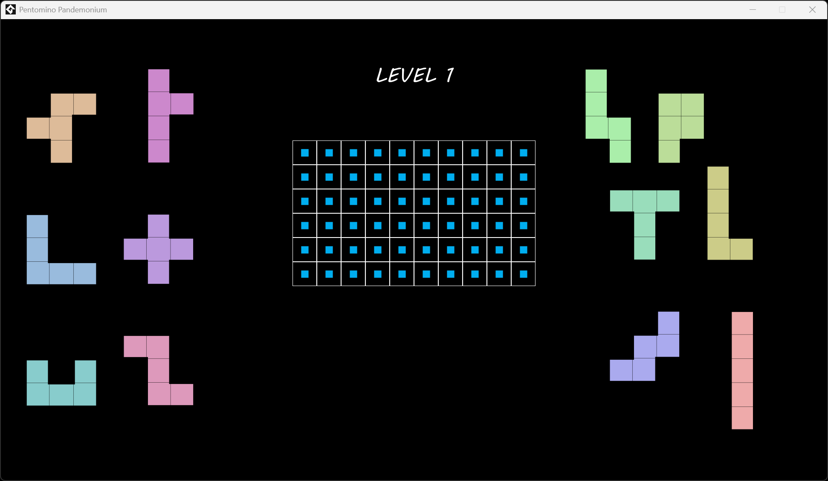
For clarity, Level 1 is repeated below, with visible blockers and a visible button:
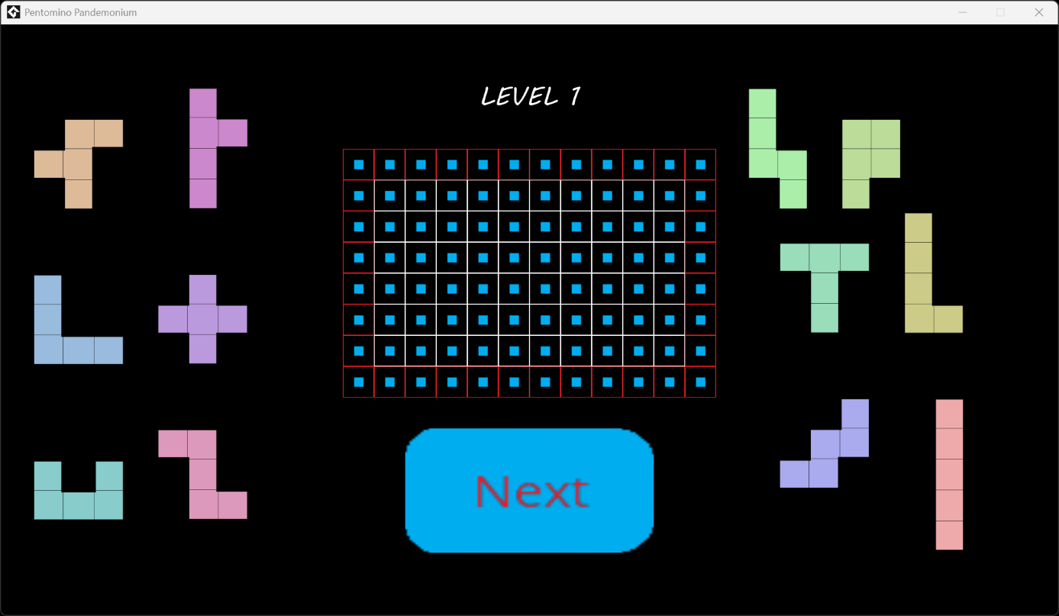

The button is always placed at the bottom of the screen, but the pieces, the title, and the grid have no standard initial location and may be scattered “wackily” on some levels. This is intentionally done in order to create visual interest on an otherwise dull background. Another level is shown below as an example:
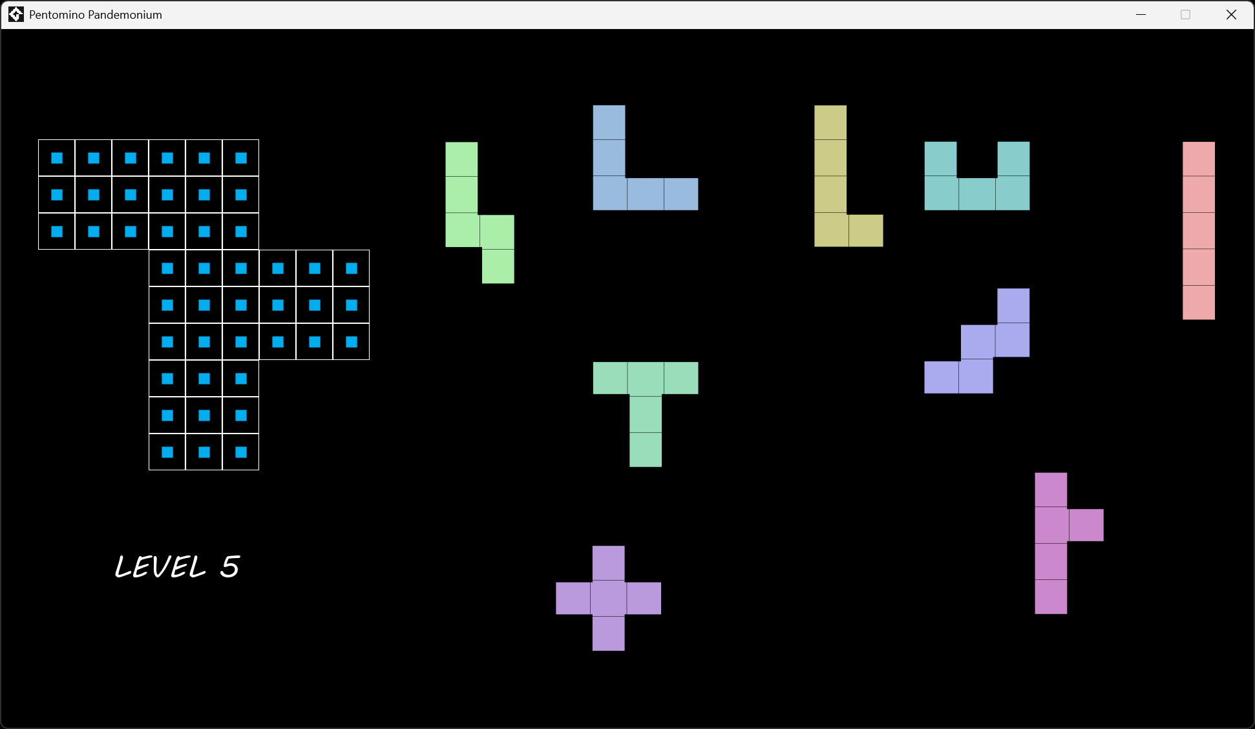
For clarity, this level is repeated below, with visible blockers and a visible button:
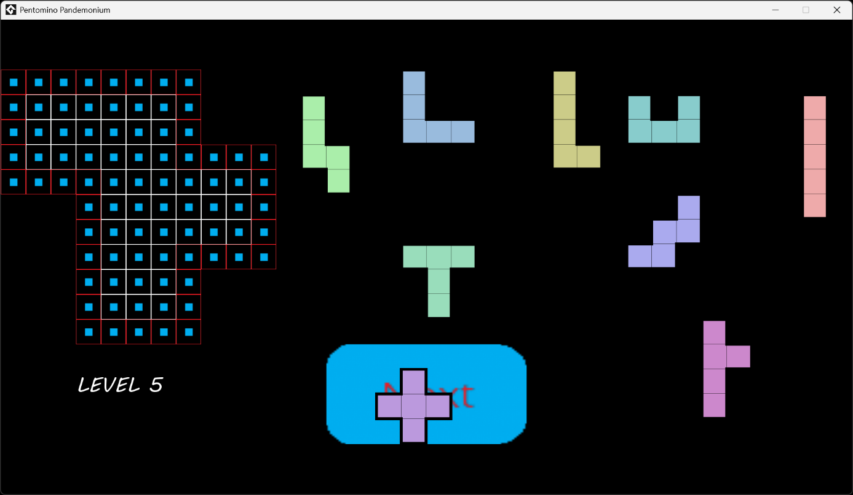
As seen in the example above, note that the grid might not be completely rectangular, and in fact is not rectangular in a majority of the levels. Furthermore, note that the X piece initially overlaps with the button.
Each level currently in the game can be viewed in Appendix A, with an example solution.

4.1. Main Menu
The main menu simply consists of the game’s title above a “Play” button, a “Credits” button and a “Quit” button (all three explained in Section 2.4) on a pitch-black background, as seen below:
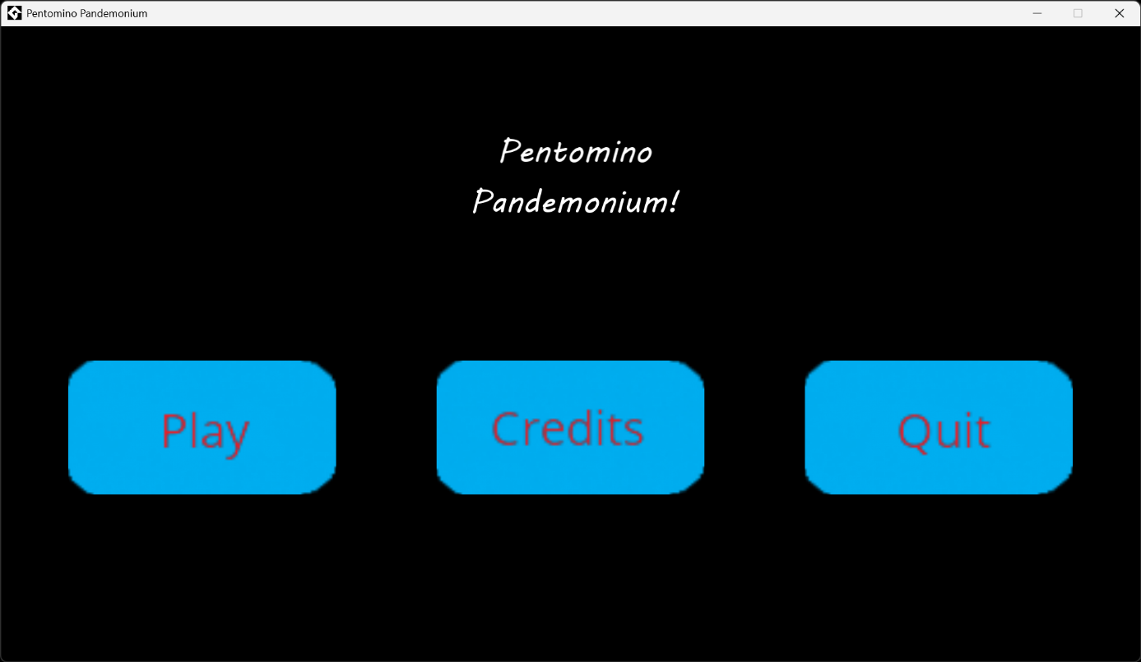

4.2. Credits “Menu”
This is a simple menu that accredits the game’s music appropriately and includes the license. A “Back” button is included as the only interactable object, and it returns the play to the main menu (as explained in Section 2.4).
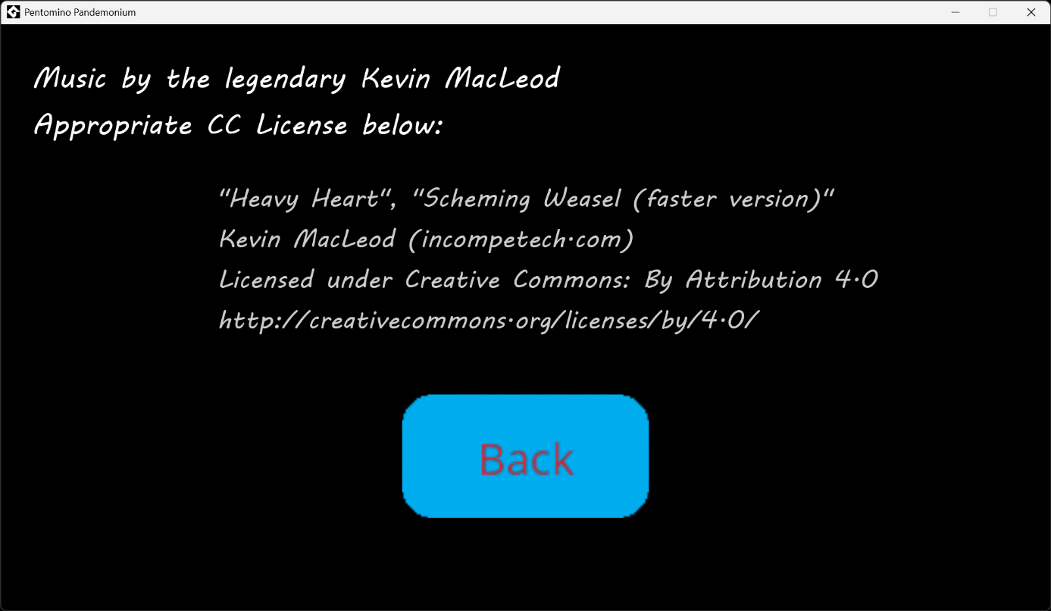

5. Game Progression
A level is considered solved/complete when each tile on its grid is covered by exactly one pentomino. The game is won (and ends) when each of the 16 levels is either skipped or solved. There is no “losing” state for the game or any level. Below is an example of a solved level:
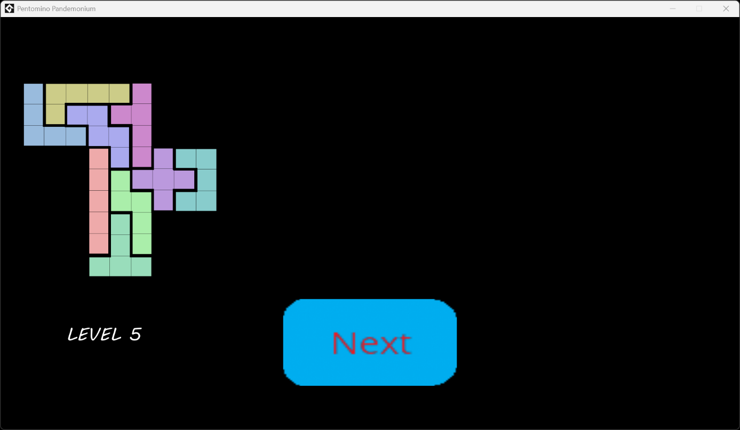

5.1. Advancing a Level
The “Play” button on the main menu sends the player to Level 1.
For each level, a “Next” button will appear when either the “Skip” key is tapped or the level is solved, allowing the player to advance to the next level. If the “Next” button is pressed during the final level, the game considers itself to be won, so it ends and closes itself.

6. Tools & Assets
The game is developed via the GameMaker game engine, a simple engine fit for beginners and making two-dimensional games (IDE Version: v2024.14.2.222, Runtime Version: v2024.14.4.268). The following subsections will list the sprites and tracks used in-game. The sprites may be subject to change in the future.

6.1. Sprites
The sprites currently used in game for the pentominoes are taken from Wikipedia (see Appendix C for details) and have been slightly edited. Currently, collision masks created via GameMaker’s tools are being used for each piece to detect collision with other objects, but those aren’t listed in this document so as to avoid clutter. The currently in-game sprites of the pentominoes (ordered as F, I, L, N, P, T, U, V, W, X, Y, and Z) are listed on the next page:


Note the thick black outer borders on each pentomino sprite.
All other sprites (tiles, blockers, buttons, and titles) are original creations made with GameMaker’s image creation tools. The sprites of tiles and blockers, while already seen in Sections 2.2 and 2.3, are repeated below, respectively:

The sprites of each type of button change when hovered over with a mouse. Below is a table that shows the difference between each state for each button. Note the cute change of text from “Quit” to “:(((“.
Default Sprite | Sprite When Hovered Over With a Mouse
 | 
 | 
 | 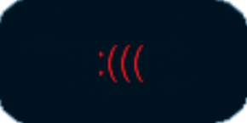
 | 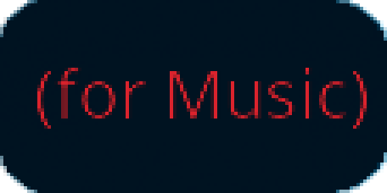
 | 

The sprites of each title are not be included here because they are simple pieces of text. The font MV Boli is currently used for them. Sample characters of the font are included below:


6.2. Soundtrack
There are two tracks of music that play during the game:
- “Heavy Heart” by Kevin MacLeod, which plays only when hovering the “Quit” button with the mouse cursor.
- “Scheming Weasel” by Kevin MacLeod, which plays during the rest of the game, starting together when the game itself is started.
Both tracks are free to be used without the worry of a copyright strike. Details are in Appendix C.

A. Appendix: Levels and Their Solutions
This appendix lists images all of the levels in the game, in order of their appearance, alongside one solution for each level. It should be noted that none of the levels have unique solutions. If more levels are added to the game, this appendix should (and will) be updated accordingly while keeping the level order intact.

A.1. Level 1

Example Solution:
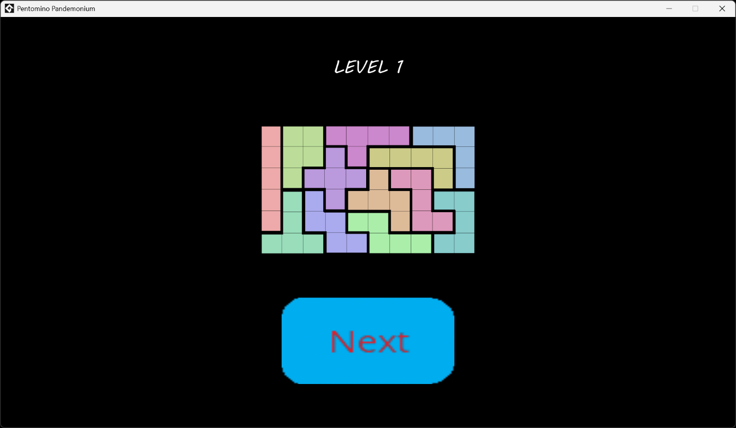

A.2. Level 2
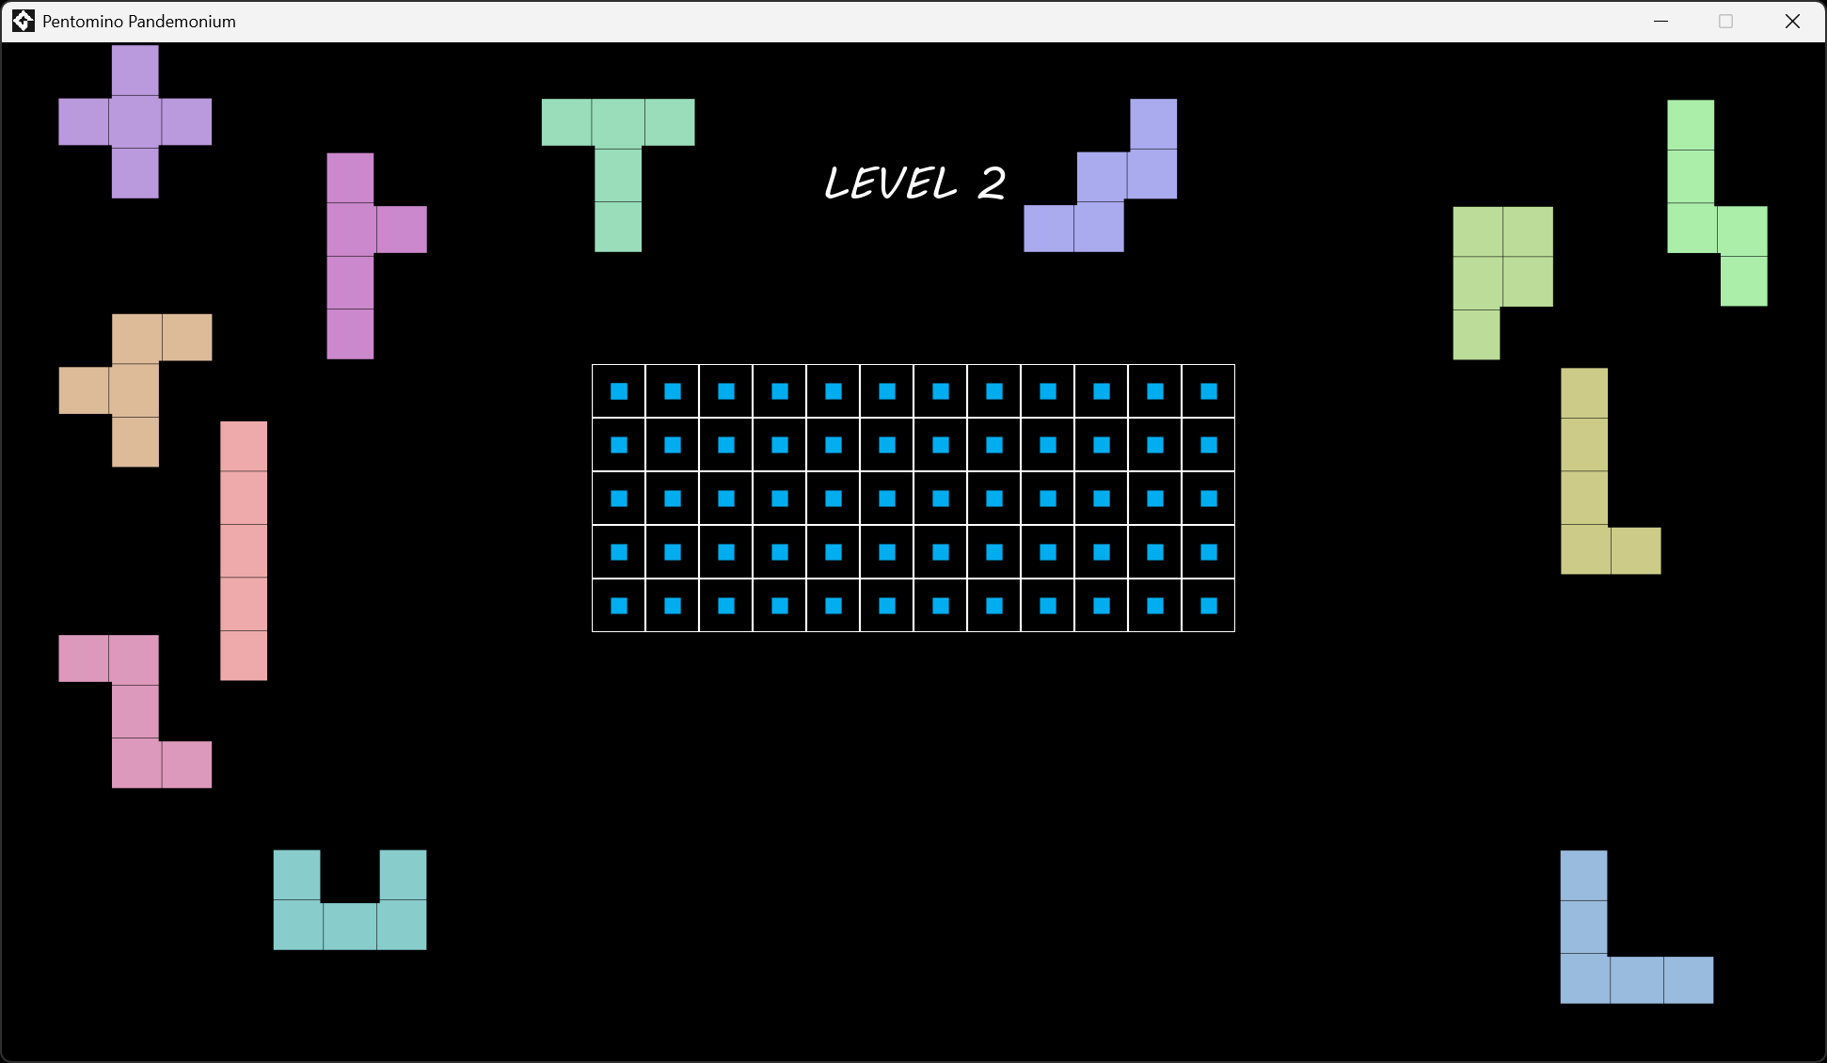
Example Solution:
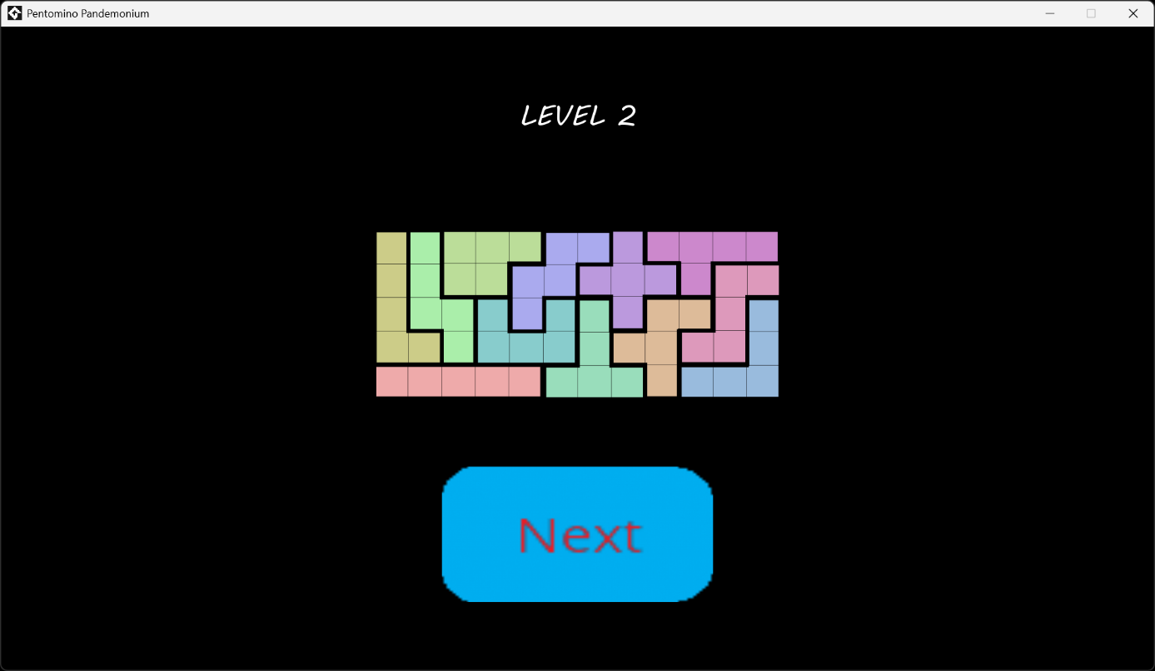

A.3. Level 3
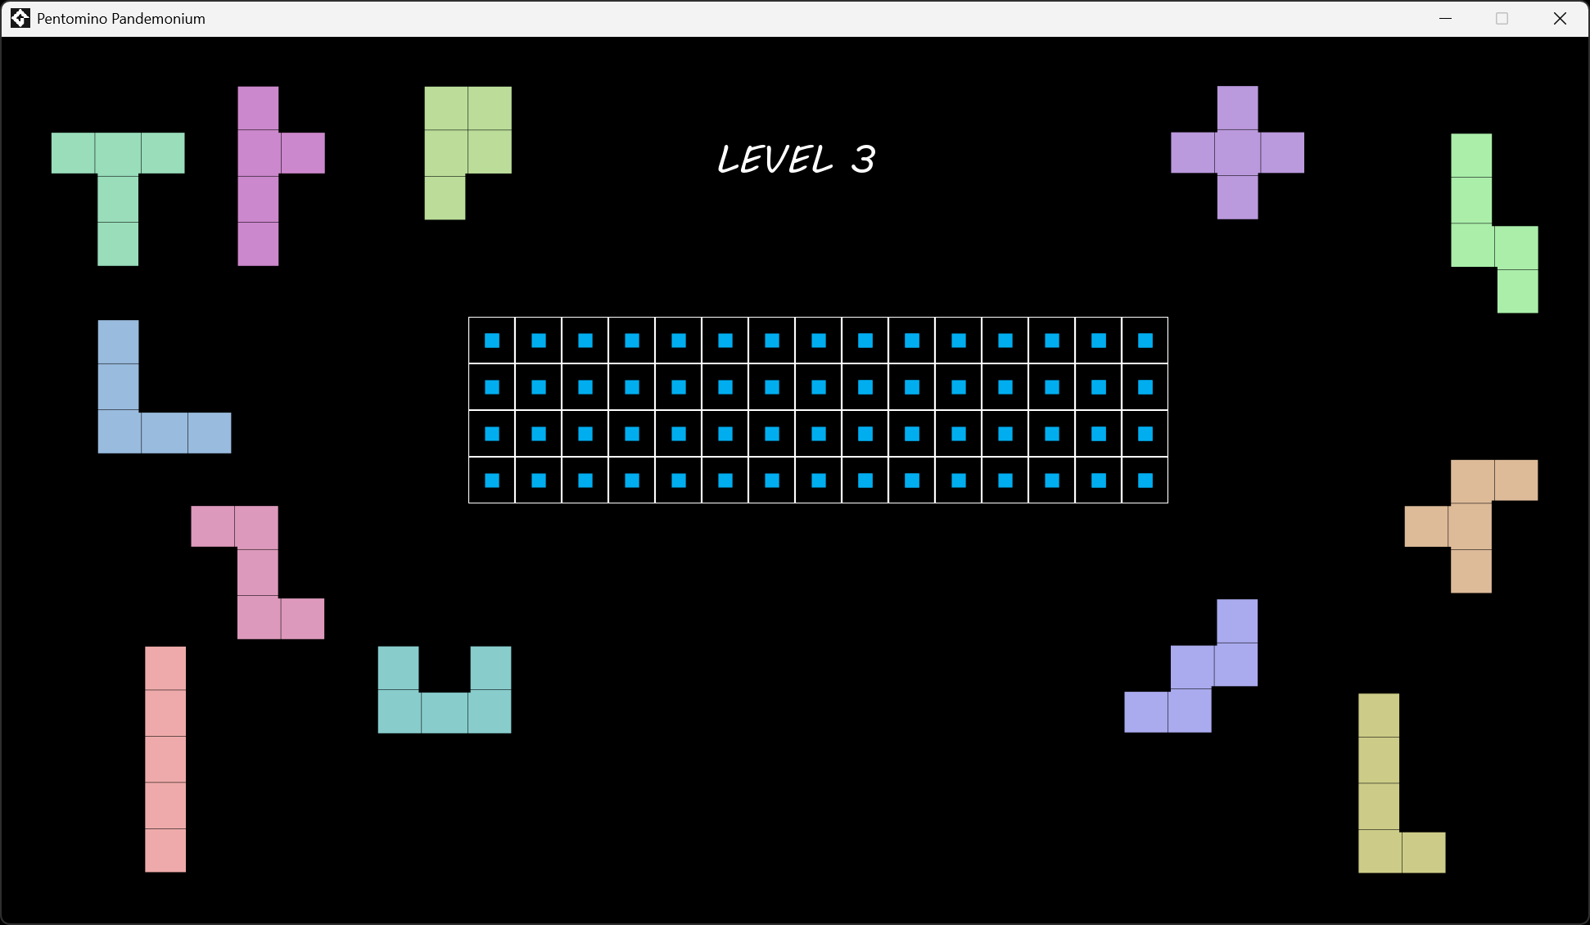
Example Solution:
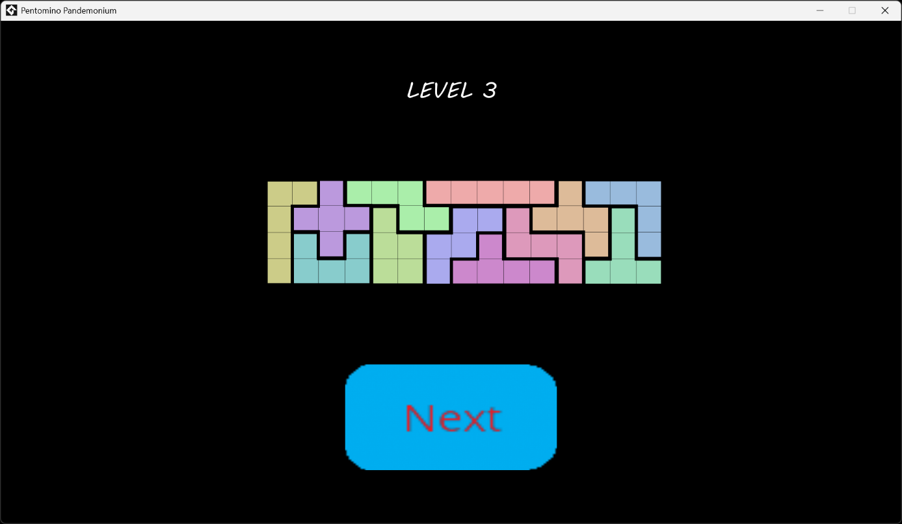

A.4. Level 4
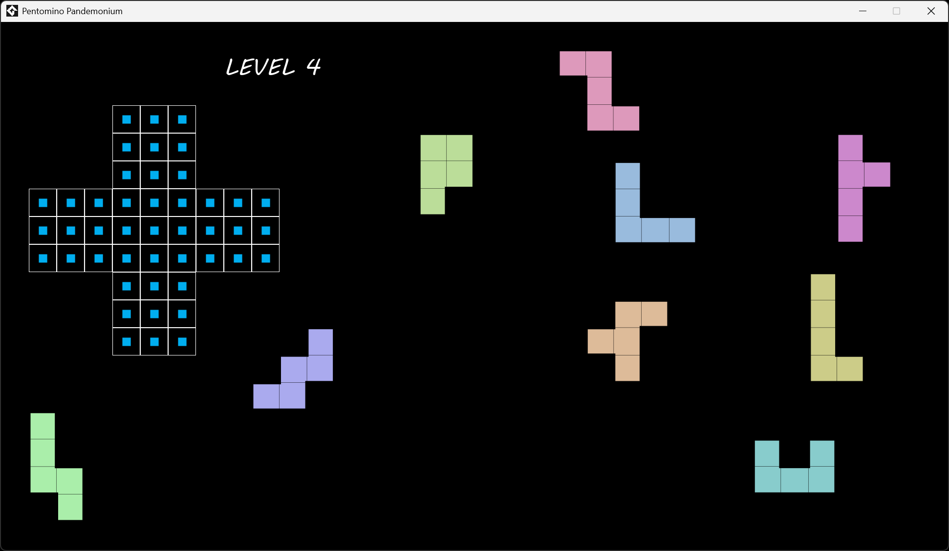
Example Solution:
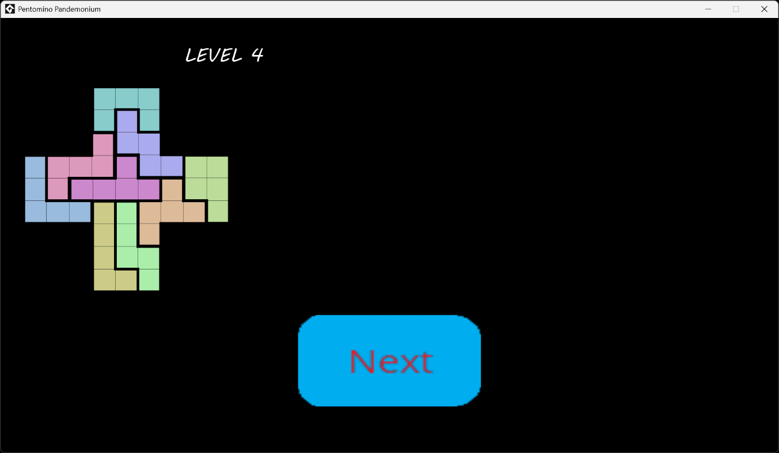

A.5. Level 5

Example Solution:


A.6. Level 6
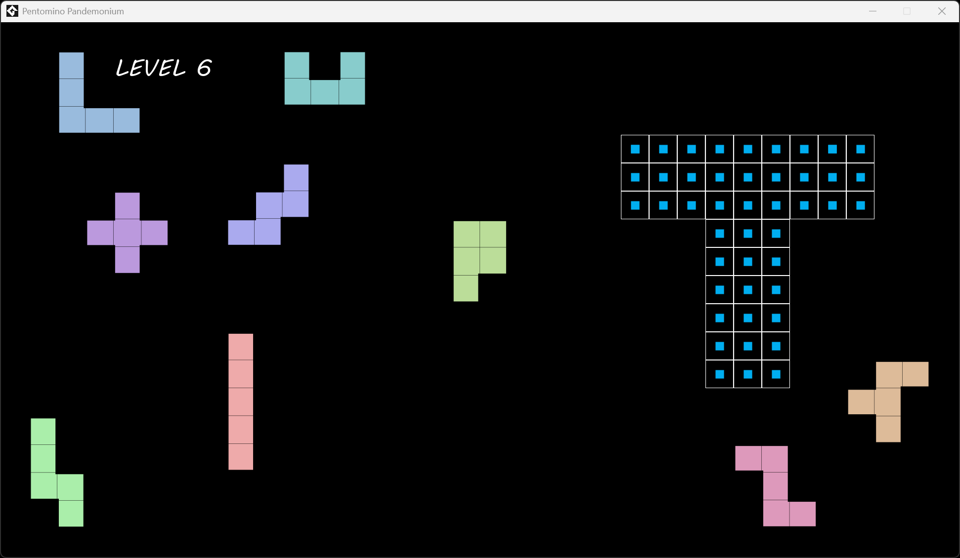
Example Solution:
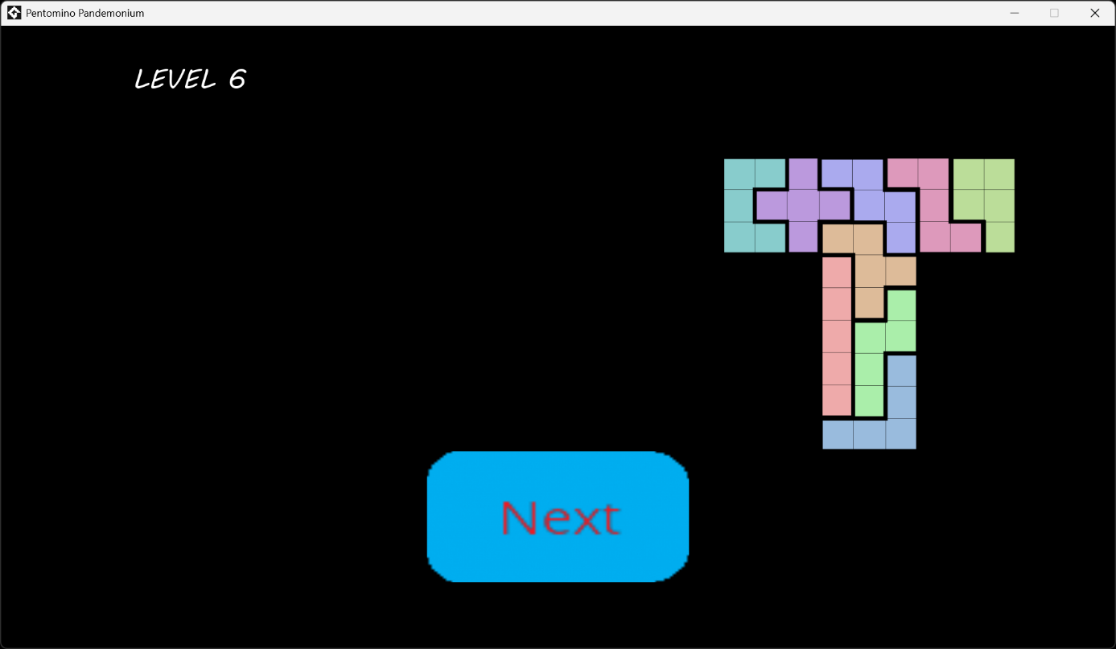

A.7. Level 7
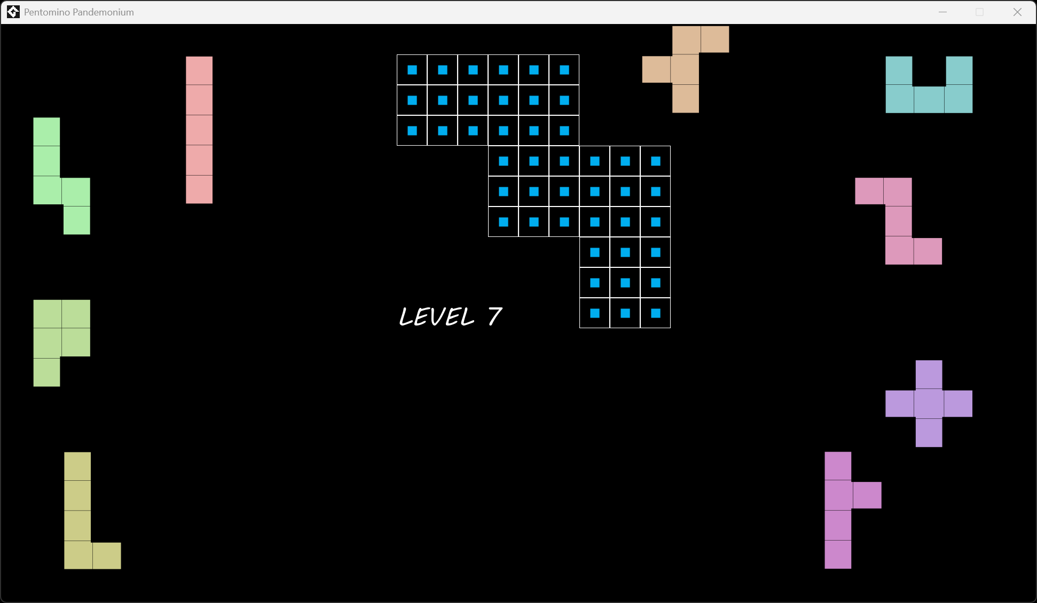
Example Solution:
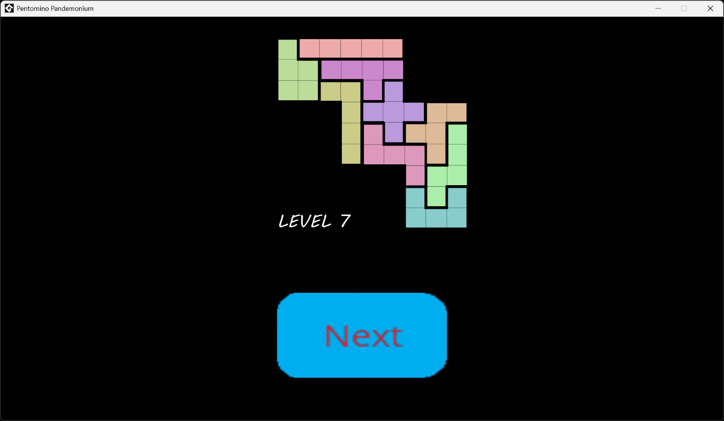

A.8. Level 8
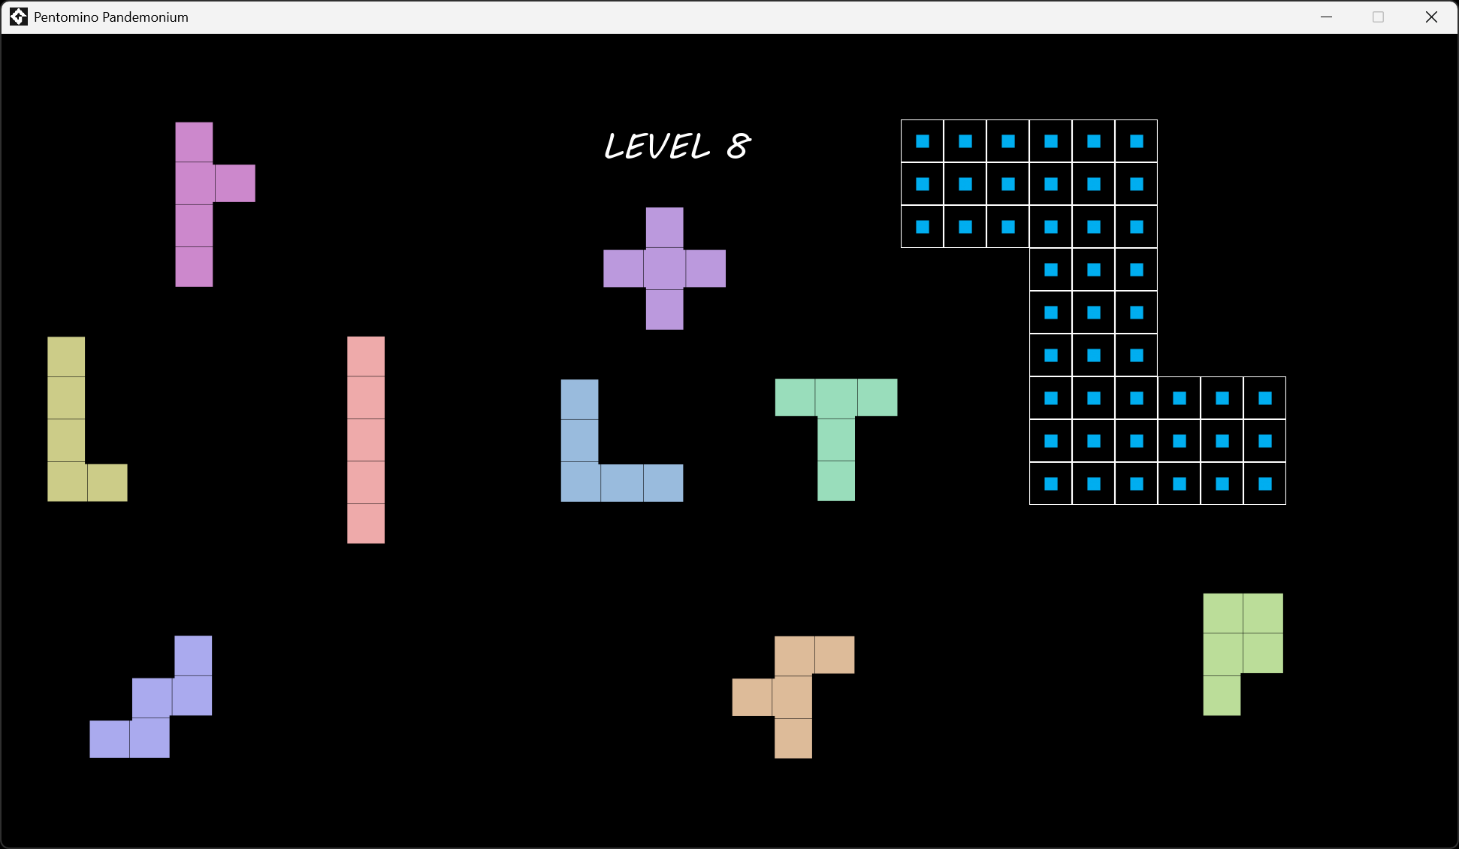
Example Solution:
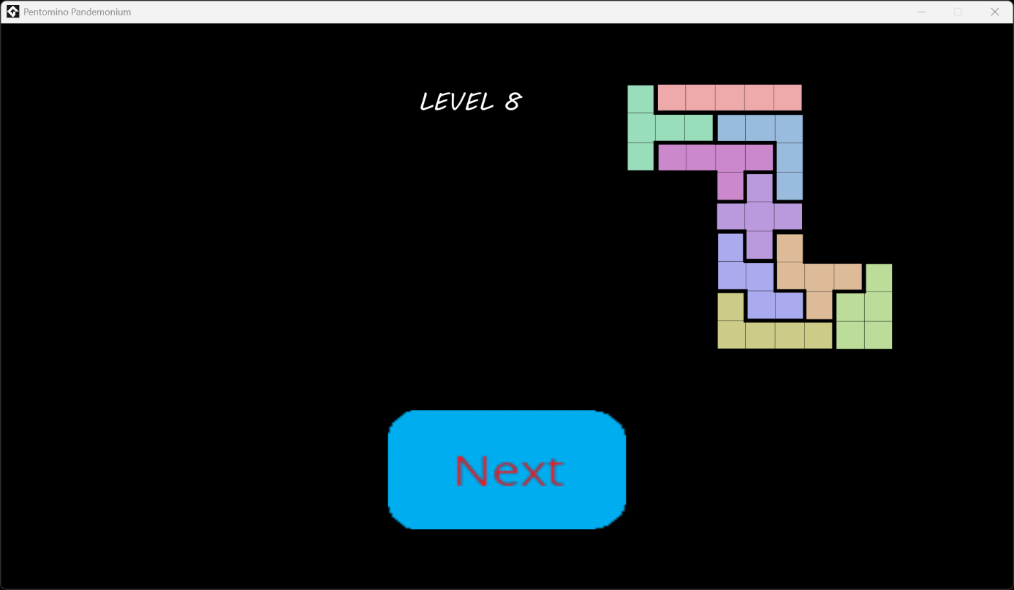

A.9. Level 9
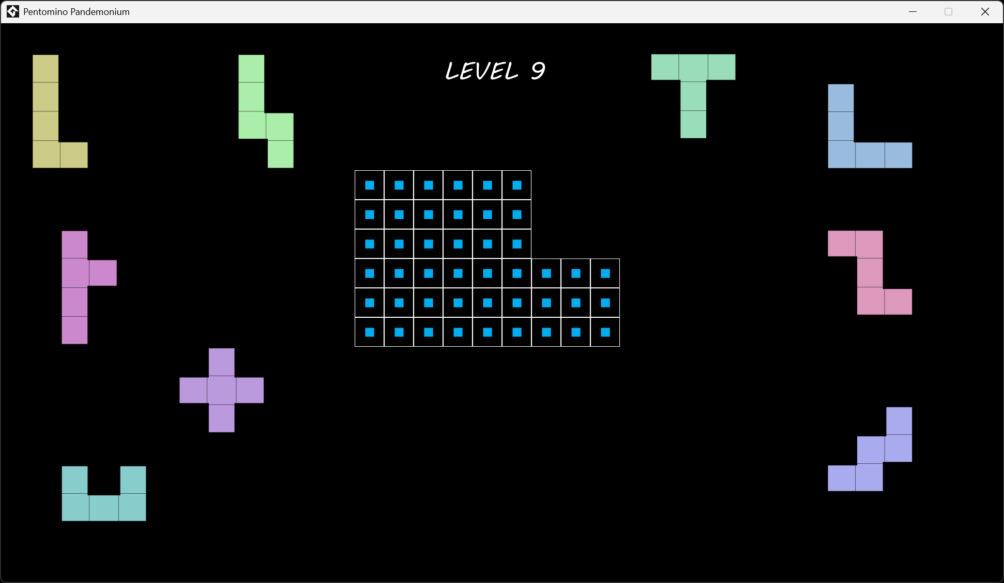
Example Solution:
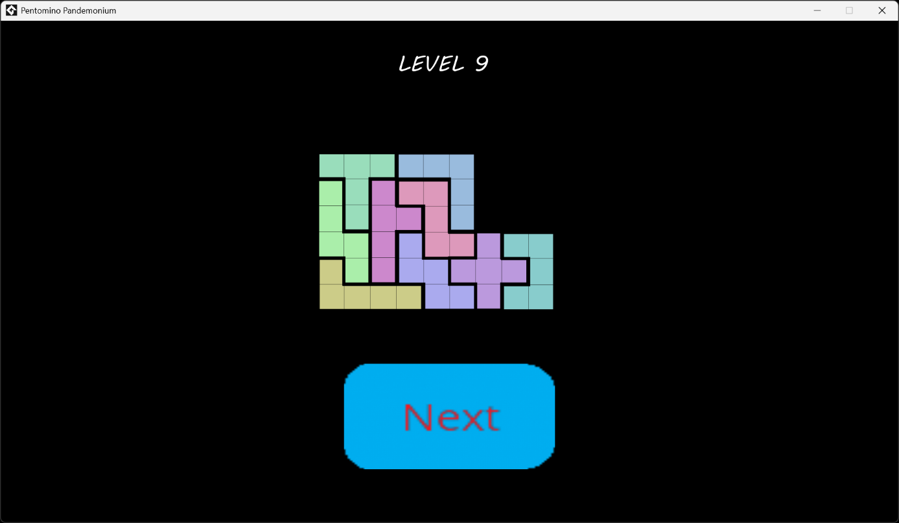

A.10. Level 10
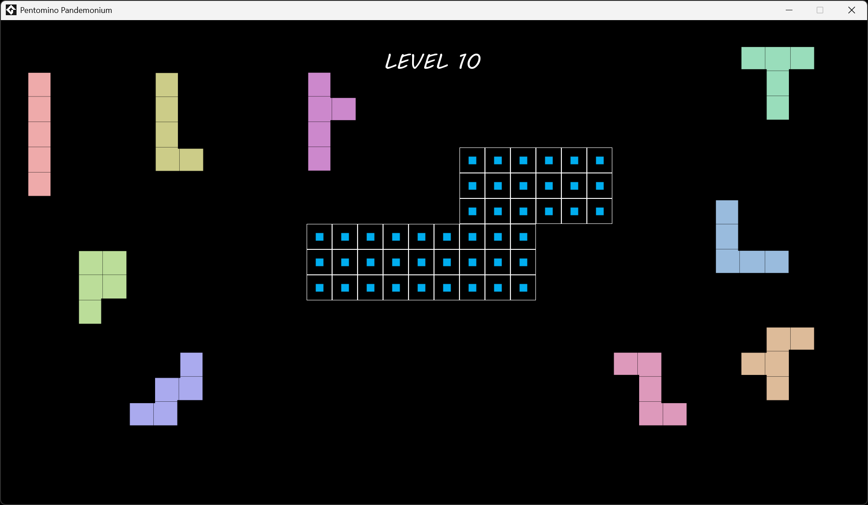
Example Solution:
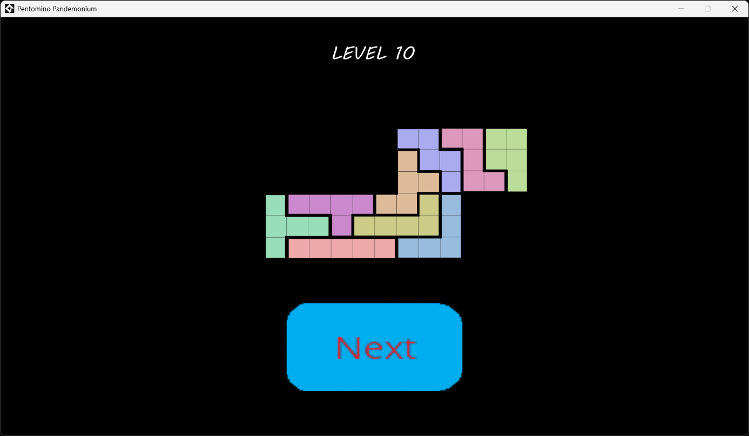

A.11. Level 11
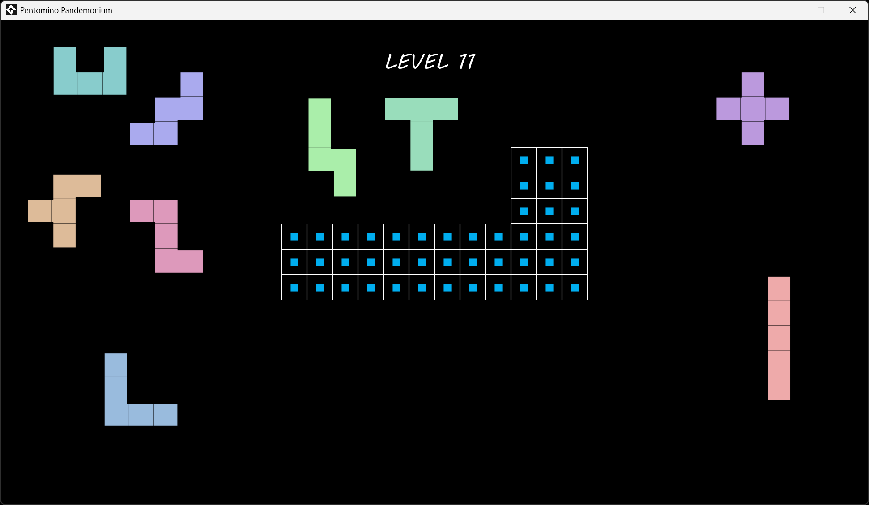
Example Solution:
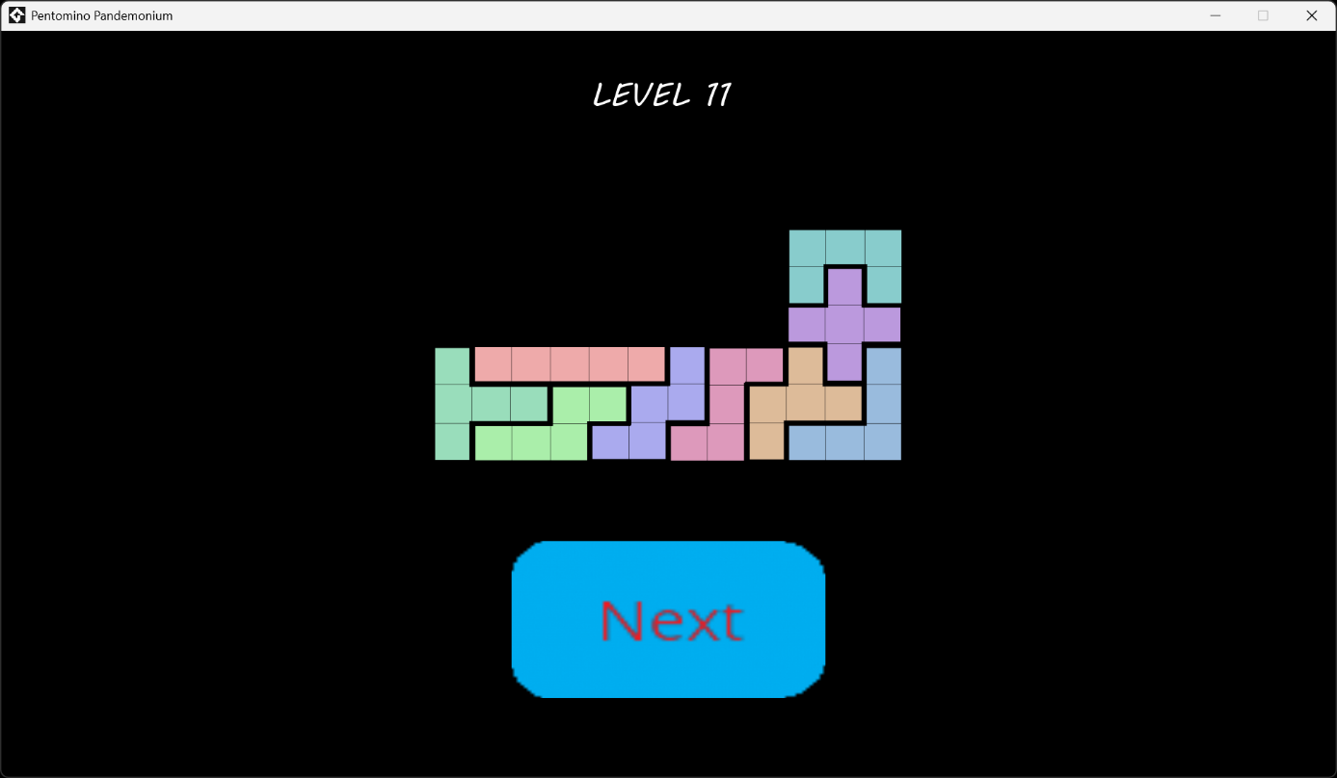

A.12. Level 12
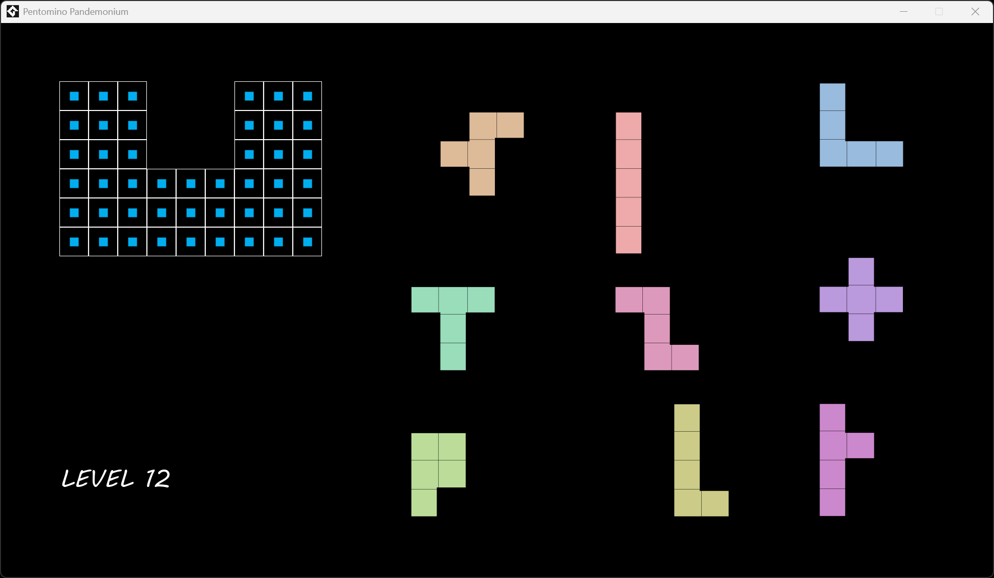
Example Solution:
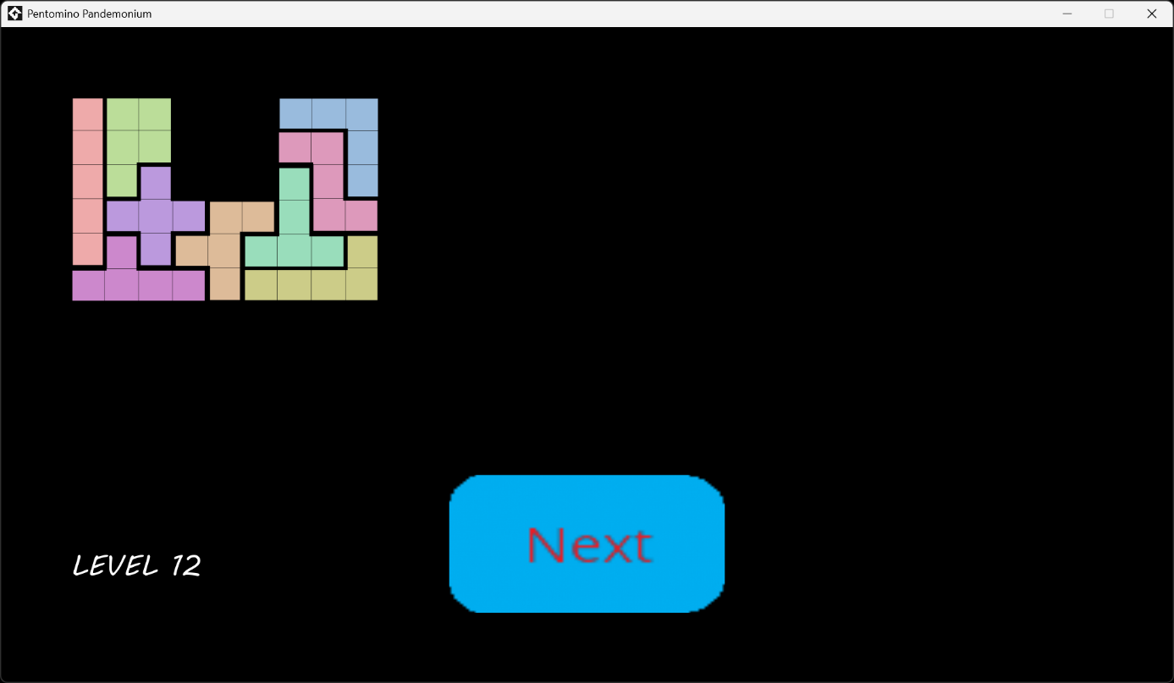

A.13. Level 13
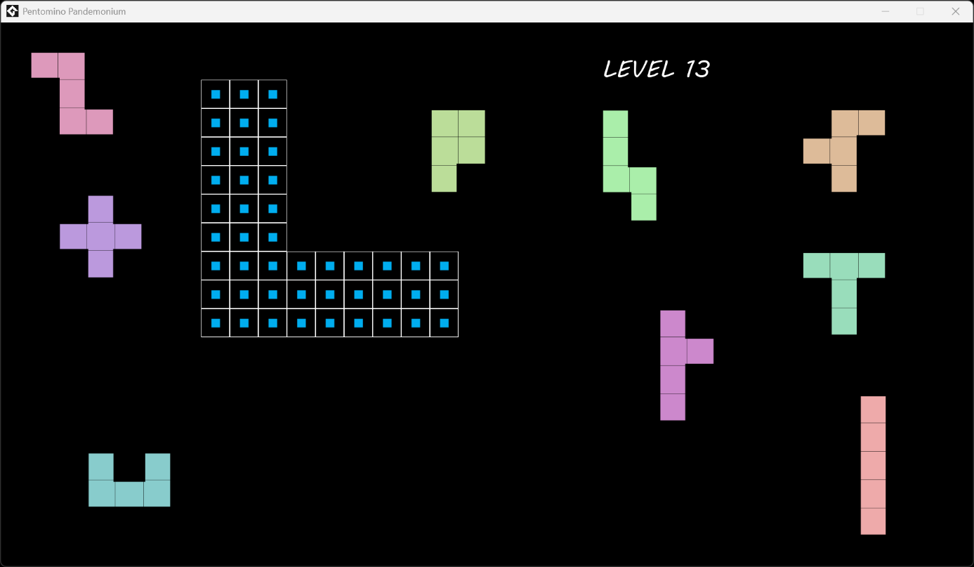
Example Solution:
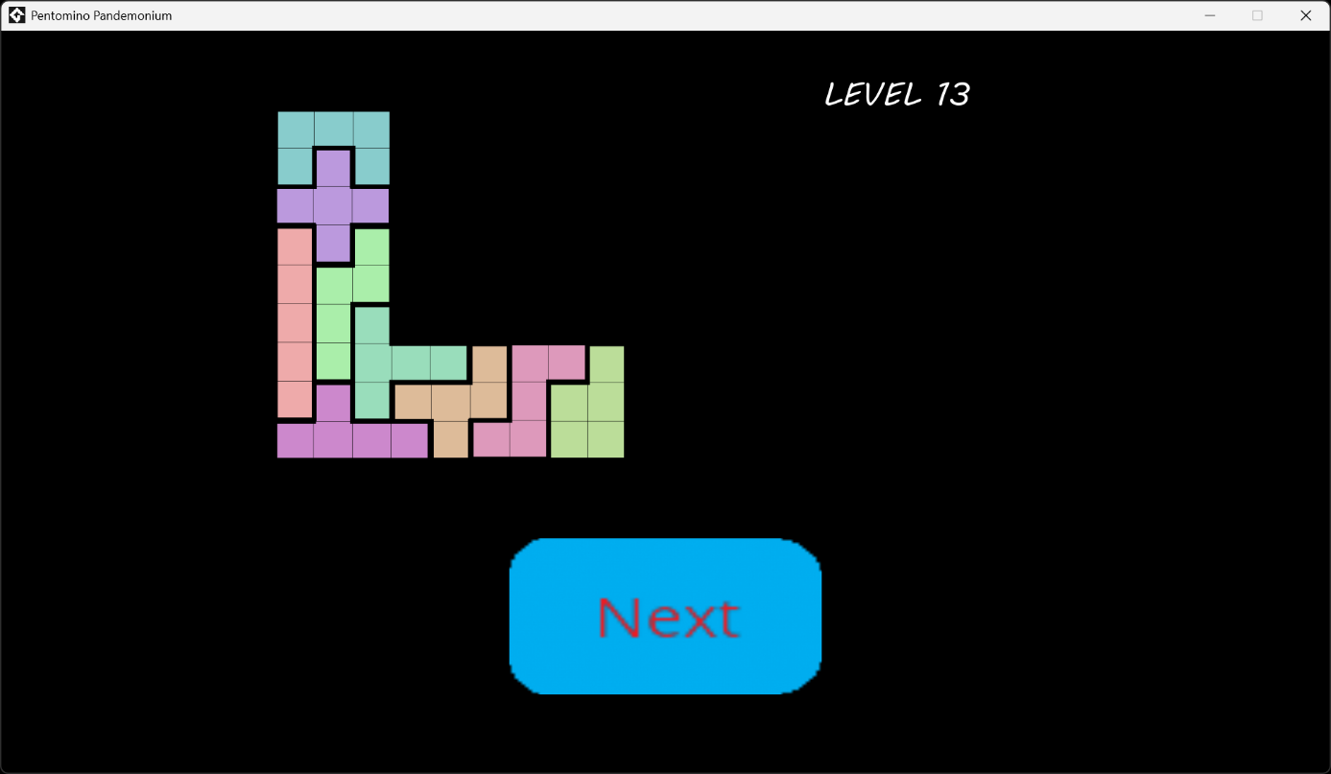

A.14. Level 14
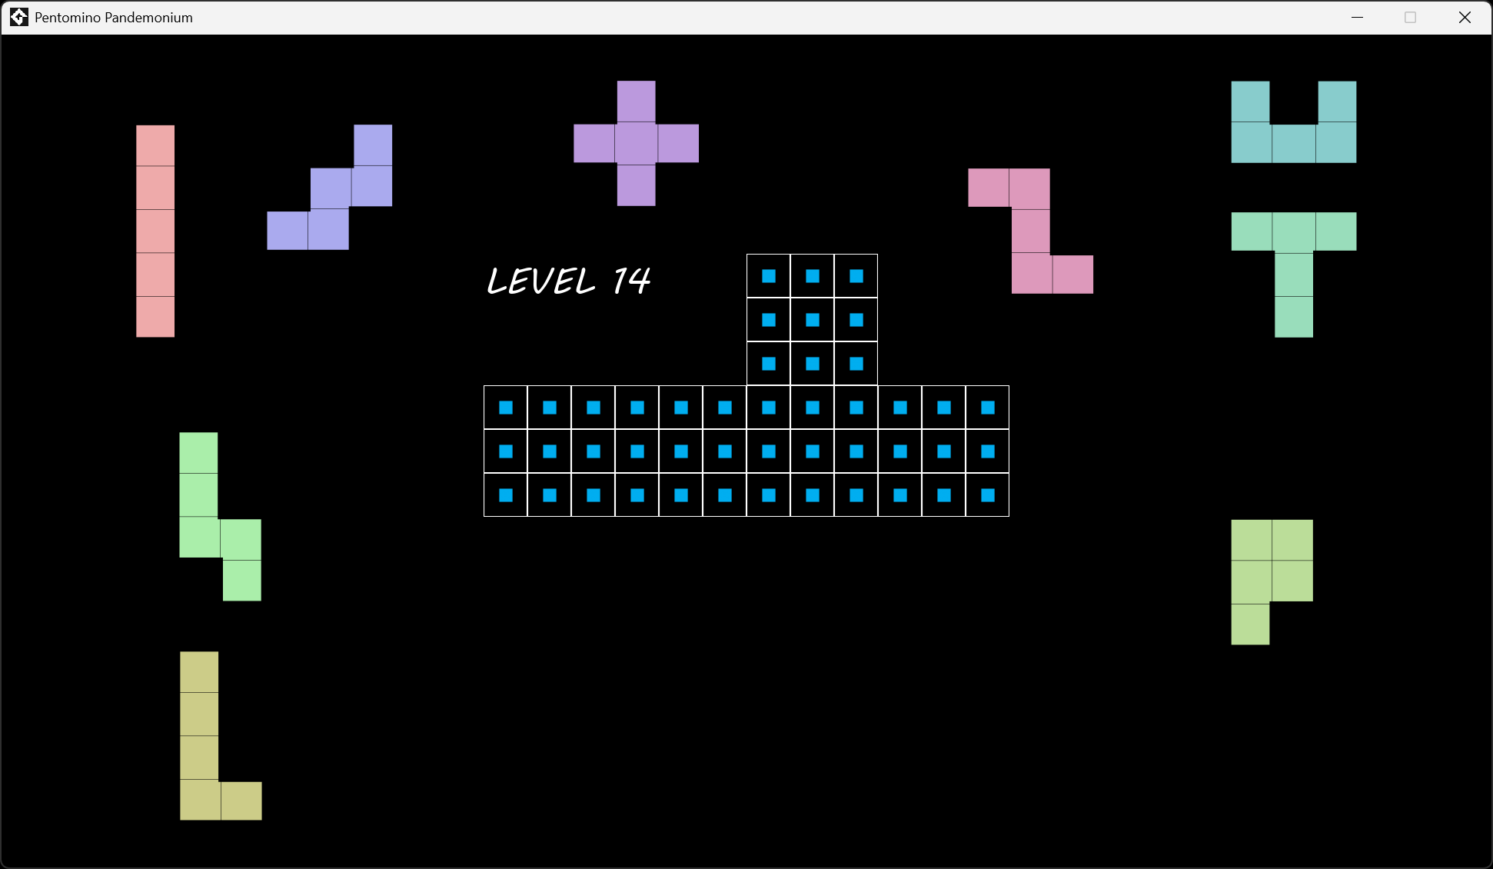
Example Solution:
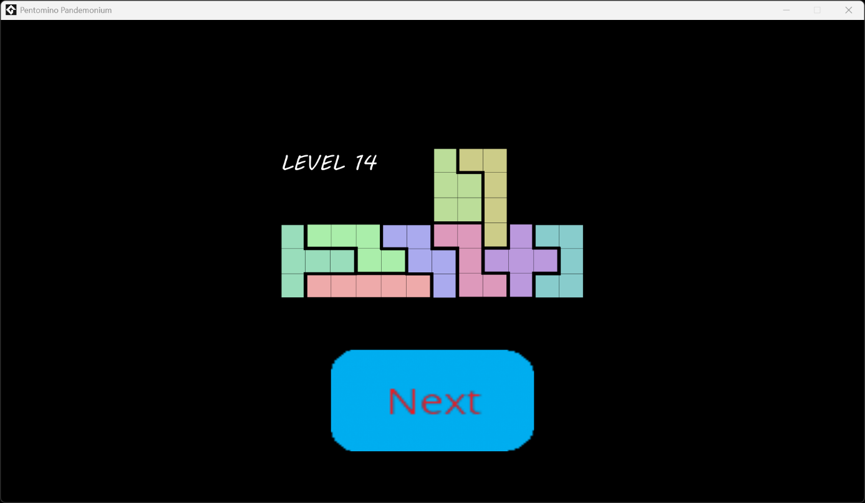

A.15. Level 15
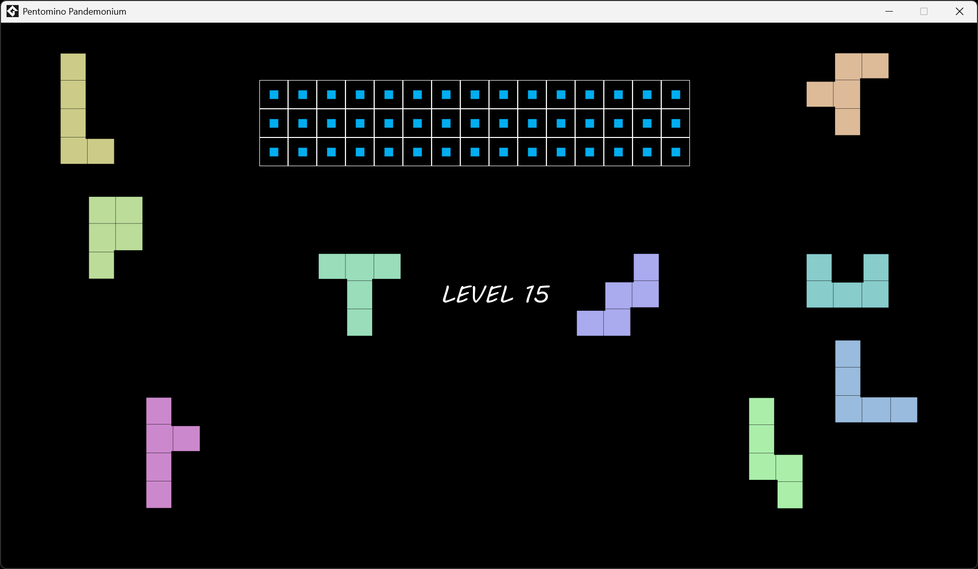
Example Solution:
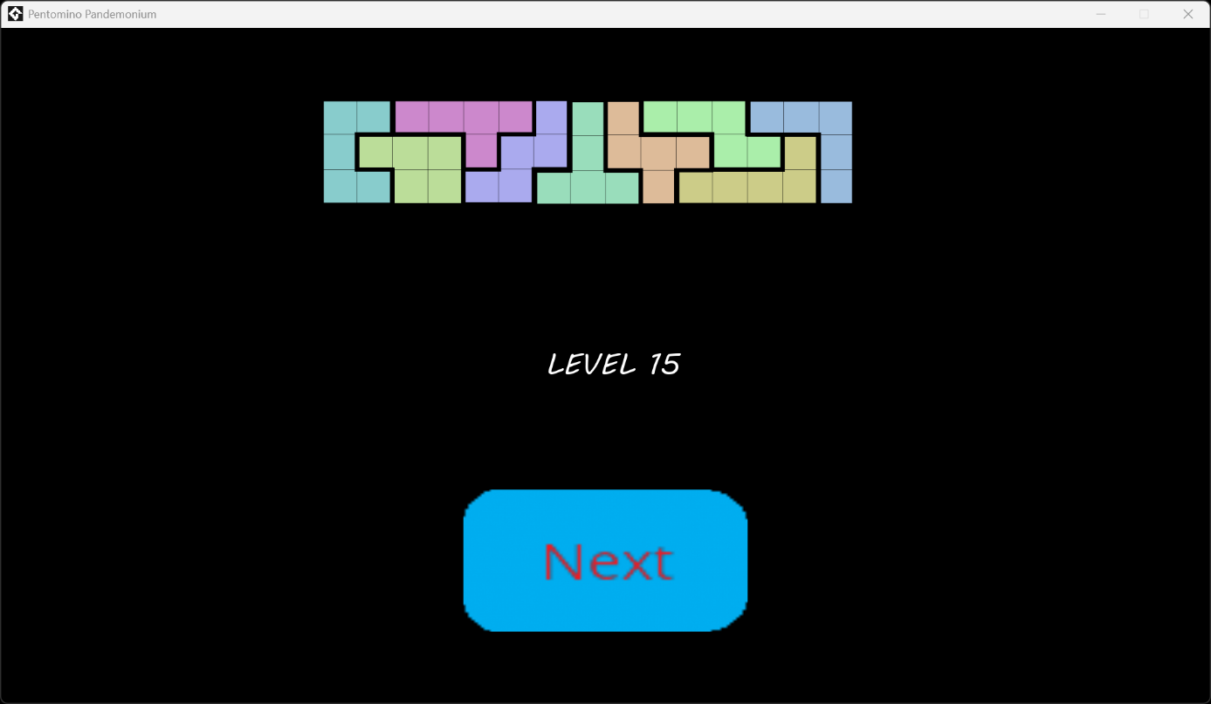

A.16. Final Level
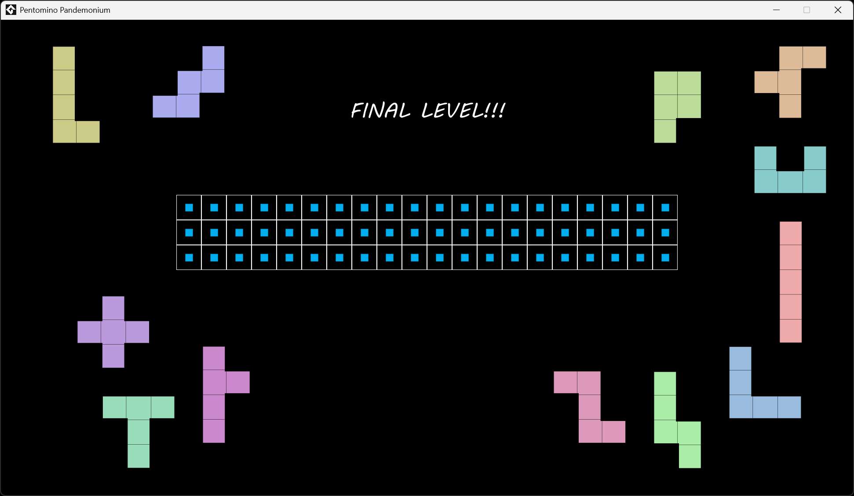
Example Solution:
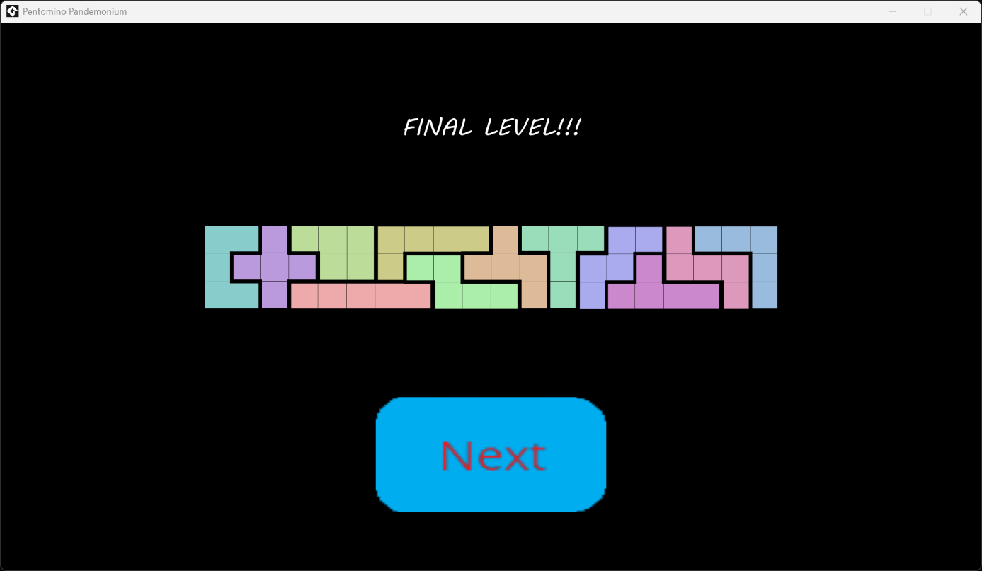

B. Appendix: Unplanned Features That Could Be Added in The Future
While the current features of this game are sufficient to be playable and enjoyable, below is a simple list of content that could be added to this game so as to slightly improve it:
- A “Level Select” screen
- A screen dedicated to explaining the controls, including the key that is used for skipping levels.
- A “Victory!” or “You Win!” screen after the final level
- A key/button, available during the levels, dedicated to returning to the main menu
- A button to reset progress on the current level
- A polychromatic background image
  - Three backgrounds: one for the main menu, one for Levels 4-15, and one for the other four levels.
- Short sound effects associated with each mechanic listed in Section 3.
There are currently no plans to add such features into the game. The current focus is on catching and fixing bugs.

C. Appendix: References
All sprites of pentominoes in this document, the solutions in Appendix A, and the naming convention for the pieces were all taken from the Wikipedia article of pentominoes: https://en.wikipedia.org/wiki/Pentomino.
Both tracks in the soundtrack are royalty-free tracks of the legendary Kevin MacLeod, and were taken from his official website, incompetech.com:
“Scheming Weasel”: https://incompetech.com/music/royalty-free/index.html?isrc=USUAN1100085
“Heavy Heart”: https://incompetech.com/music/royalty-free/index.html?isrc=USUAN1600002
Below is the appropriate Creative Commons license for the two tracks:
"Heavy Heart", "Scheming Weasel (faster version)"
Kevin MacLeod (incompetech.com)
Licensed under Creative Commons: By Attribution 4.0
http://creativecommons.org/licenses/by/4.0/

The sprites for tiles, blockers, buttons, and titles are all self-made using GameMaker’s tools. (IDE Version: v2024.14.2.222, Runtime Version: v2024.14.4.268)
To download GameMaker: https://gamemaker.io/en/download
To download the latest version of the game: https://github.com/egebalcioglu1999/Pentomino-Pandemonium

